**Inter-VLAN Routing Activity Documentation**

1. Set up the required desired device for the activity.

1. Put labels.

1. Connect using copper straight through. I follow the configured wires. I configured the router and configured the IP addresses of each PCs. Reference is FREE CCNA Lab 007: Inter-VLAN Routing.

Note: PC1 can ping PC3 while it cannot ping PC2 and P4

PC3 can ping PC1 while it cannot ping PC4 and P2

PC2 can ping PC4 while it cannot ping PC1 and P3

PC4 can ping PC2 while it cannot ping PC3 and P1

Findings: *Computer in same vlan can communicate but inter vlan is not working.*

Switch 1 and 2 Config

Trunk Config

Creating Sub Interfaces in Router

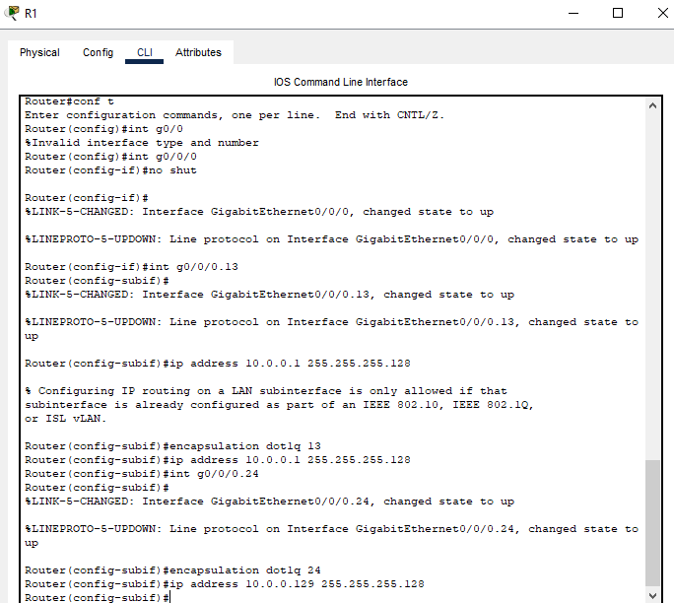

Making Trunk in Switch 1

Then I set the default gateway for each PCs

PC 1 and PC 3 to 10.0.0.1

PC 2 and 4 to 10.0.0.129

1. Troubleshooting: Testing Pings

All Ping should work.

**References**

FREE CCNA Lab 007: Inter-VLAN Routing

https://www.youtube.com/watch?v=3II2RwiXImg

FREE CCNA Lab 008: Inter-VLAN Routing (Router on a Stick) https://youtu.be/iIDkr4Kq7io?feature=shared